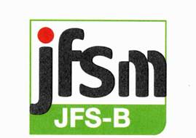

JFSM登録番号

Letter of Conformance

Date of Issue: Month Date, 202X

We hereby attest that, in accordance with the JFS Audit and Conformity Assessment Program Document of the Japan Food Safety Management Association,

XX Co., Ltd.
(XX Factory)（適合証明を受けた工場）

conforms to the JFS-B standard including the Codex HACCP requirements with the following scope of conformance:

Scope of Conformance
Location: XX Japan（工場所在地）
Product(Group): （製品群）
Sector・Sub Sector: EX（セクター・サブセクター）
Date of Registration: Month Date, 202X（登録日）
Applicable Standard: JFS-B, Version X（適用規格）
Expiry Date: Month Date, 202X（適合証明期限）

YY Co., Ltd.（監査会社名）
代表者名, Representative Director (肩書き)
住所XX, Japan

Lead Assessor（代表監査員）: Assessor(監査員）:
Reviewer（判定員）:

